Contents
1.Introduction 2
2. Key Components 3
3. Host Application (Shell / Container) 4
3.2What the Shell Owns vs What MFEs Own 4
3.3 Global Layout (Header / Sidebar / Footer / Workspace) 5
3.4 Global Navigation and Menu Orchestration 6

1.Introduction
Micro-Frontend approach to support a large-scale platform with multiple business domains and independently evolving modules. It is designed to fit enterprise scenarios—such as ERP systems—where the platform includes modules like HR, Inventory, Sales, Finance, Procurement, CRM, and Reporting, while still delivering unified user experience.
In this model, the platform is composed of a central Host Application (Shell/Container) and multiple domain-based micro-frontends. The Shell/Container serves as the main platform entry point and orchestration layer, responsible for the shared application frame (such as navigation, layout, and global context), while each domain module is implemented as an independent micro-frontend (for example: MFE-HR, MFE-Inventory, MFE-Sales, MFE-Finance).
Each micro-fronted is treated as a mini application with clear ownership and internal boundaries. Within each micro-frontend, the following:
- Clean Architecture for separation of domain logic, application flow, infrastructure, and presentation
Across all micro-frontends, a shared Atomic Design base is used to support structured UI composition and reusable interface building blocks.
In addition, the platform includes shared components and utilities to ensure consistency across modules (for example: common UI primitives, shared utilities, API base integration, authentication/session helpers, localization, and telemetry support).
This approach enables the ERP frontend to scale in a controlled and maintainable way by combining:
- Modular business-domain ownership
- Consistent platform user experience
- Shared platform standards
- Maintainable internal architecture per module

2. Key Components
- Host Application (Shell / Container)
- Domain Micro-Frontends (MFE Modules)
  - MFE-HR
  - MFE-Inventory
  - MFE-Sales
  - MFE-Finance
  - MFE-Procurement
  - MFE-CRM
  - MFE-Reporting
- Micro-Frontend Internal Architecture
  - Clean Architecture
  - Atomic Design Base
- Shared Components Layer
- Shared Utilities / Platform Services Layer
- Micro-Frontend Registration / Manifest Contract
- Routing and Navigation Model
- Cross-Micro-Frontend Integration / Communication Model
- Observability, Logging, and Error Handling Foundation

3. Host Application (Shell / Container)
The Host Application (Shell / Container) is the central entry point of the platform and the orchestration layer for all micro-frontends. It provides the shared application frame and coordinates how domain modules are discovered, loaded, and presented to the user.
The Shell is responsible for establishing a consistent platform experience across all modules while allowing each micro-frontend to remain independently implemented and evolved.
Core responsibilities include:
- Providing the global application layout and frame
- Managing top-level navigation and menu orchestration
- Initializing authentication and user session context
- Applying permission-based module visibility and route access
- Registering and loading micro-frontends
- Providing shared global providers (theme, localization, tenant context, telemetry)
- Handling global error boundaries and fallback behavior
- Exposing an integration contract for micro-frontends

3.2What the Shell Owns vs What MFEs Own
The Shell Owns
- Platform entry point
- Global layout (header, sidebar, footer, workspace frame)
- Top-level routing (module base routes)
- Global navigation/menu rendering
- Authentication bootstrap and session initialization
- Permission-based visibility of modules and menu items
- Shared providers and cross-cutting context
- MFE discovery, registration, and runtime orchestration
- Global error boundaries and fallback UI
- Platform-level telemetry context
Each Micro-Frontend Owns
- Domain-specific pages and workflows
- Internal routing under its assigned base route
- Domain UI components and page composition
- Feature state and UI interactions
- Domain validation and frontend business logic
- Backend integration adapters for that domain
- Local error handling (inside module scope)
- Module-specific telemetry events
Boundary rule: Shell owns the platform frame and orchestration; MFEs own the domain experience inside their module boundary.

3.3 Global Layout (Header / Sidebar / Footer / Workspace)
Shell provides the shared layout structure used by all modules to ensure unified user experience.
Typical Layout Regions
- Header
  - Platform branding/logo
  - User profile/session actions
  - Notifications entry
  - Language switcher
  - Tenant/company selector (if applicable)
- Sidebar
  - Main module navigation (HR, Inventory, Sales, Finance, etc.)
  - Grouped navigation sections
  - Permission-aware menu items
  - Collapsible behavior (optional)
- Footer
  - Environment/version indicators (optional)
  - Support/help links (optional)
  - Copyright/product info
- Workspace / Content Area
  - Main rendering area where the active micro-frontend is mounted
  - Page-level shell wrappers (breadcrumbs, page title host zone if applicable)
  - Loading/fallback state rendering area

3.4 Global Navigation and Menu Orchestration
Shell is responsible for orchestrating global navigation and building the platform menu across all registered modules.
Responsibilities
- Resolve available modules from registration/manifest data
- Build the sidebar/top navigation structure
- Apply ordering/grouping rules
- Apply feature flags (if enabled/disabled)
- Filter menu items based on user permissions/claims
- Route users to the selected module base route
Menu Source Strategy
The menu should be generated from a combination of:
- Shell configuration (groups, ordering, platform rules)
- MFE manifests (module metadata, route, display name, icon, permissions)
This ensures the Shell maintains control over the user experience while allowing modules to declare their integration metadata.
Best practice: Shell renders the menu; MFEs provide registration metadata, not direct menu rendering logic.

3.5 Authentication / Session Bootstrap
Shell performs the initial authentication and session bootstrap process before loading protected modules.
Responsibilities
- Detect authentication state (authenticated / unauthenticated)
- Trigger login flow or redirect to identity provider (if required)
- Retrieve and initialize session context (tokens, user profile, tenant/company context)
- Initialize user claims/permissions
- Handle token refresh lifecycle (or delegate via shared auth SDK)
- Expose session/auth context to MFEs through shared providers/contract
Expected Outcome
Before the domain MFE is mounted, Shell should have established:
- authenticated user identity
- current tenant/company/branch context (if applicable)
- permission/role claims
- locale/language preferences (if platform-level)
- global telemetry correlation context (if applicable)
This guarantees all modules start with a consistent and trusted platform context.

3.6 Permission-Based Module Visibility
The Shell controls which modules and navigation entries are visible and accessible based on the user’s permissions, roles, or claims.
Shell Responsibilities
- Evaluate permissions for each registered module
- Hide or disable unavailable modules in the menu
- Prevent navigation to unauthorized module routes
- Render unauthorized fallback screens/messages when needed
- Pass relevant permission context to MFEs (if required for finer UI control)
Important Rule
Permission checks in Shell improve UX and navigation control, but they do not replace backend authorization.
Security rule: The Shell enforces UI-level visibility and routing guards; backend services remain the source of truth for access control.

3.7 Global Providers (Theme, i18n, Tenant, Telemetry)
The Shell initializes and hosts platform-wide providers that should be shared consistently across all micro-frontends.
Typical Global Providers
- Theme Provider
  - Design tokens
  - Light/dark mode (if applicable)
  - UI density/layout settings (optional)
- Localization / i18n Provider
  - Language selection (e.g., English / Arabic)
  - Locale formatting behavior
  - RTL/LTR direction support
- Tenant / Company Context Provider
  - Current tenant/company/branch
  - Context switching support (if platform supports it)
- Telemetry / Logging Context Provider
  - Correlation IDs
  - User/session metadata (as permitted)
  - Tenant/module context propagation support
- Auth / Session Provider
  - User identity
  - Claims/permissions
  - Session status
Shell should provide these through stable contracts so all MFEs consume the same platform context model rather than re-implementing it independently.

3.8 MFE Loading / Orchestration Lifecycle
Shell manages the lifecycle of micro-frontends from registration to rendering.
Typical Lifecycle Steps
- Initialize Shell
  - Start app bootstrap
  - Initialize providers (auth, theme, i18n, telemetry, tenant)
- Load Module Registry / Manifests
  - Discover registered MFEs
  - Validate required metadata (id, route, permissions, load entry)
- Build Navigation
  - Filter modules by permissions/feature flags
  - Render menu structure
- Resolve Route
  - Match current URL to a module base route
- Load Target MFE
  - Load module entry/runtime bundle
  - Initialize integration context
  - Mount into workspace
- Handle Runtime States
  - Loading state while MFE loads
  - Error fallback if MFE fails
  - Unmount/remount when navigating to another module
- Track Telemetry
  - Log module load success/failure
  - Capture route/module navigation events
Lifecycle Design Goal
A failure in one MFE should not crash into the entire platform. The Shell must isolate module failures and preserve the platform frame.

3.9 Error Boundaries and Fallback Behavior
Shell provides platform-level resilience through global error boundaries and fallback behavior.
Shell-Level Error Handling Responsibilities
- Catch rendering/runtime errors at the module boundary
- Display a user-friendly fallback screen for failed modules
- Preserve Shell navigation and platform frame
- Log error details with module context
- Offer retry/reload actions (where applicable)
Fallback Scenarios
- MFE bundle fails to load
- MFE runtime initialization fails
- Manifest is invalid/missing required fields
- Unauthorized route access
- Unsupported route/module not found
Example Fallback Behavior
If MFE-Reporting fails to load:
- Shell keeps header/sidebar visible
- Workspace shows a fallback panel:
  - “Reporting module is temporarily unavailable”
  - Retry action
  - Support reference/error ID (optional)

3.10 Shell Integration Contract with MFEs
Shell and each micro-frontend must communicate through a clear and stable integration contract to prevent tight coupling.
Contract Purpose
The integration contract defines how an MFE:
- registers itself (manifest)
- is loaded by the Shell
- receives host/platform context
- interacts with platform capabilities (navigation, telemetry, auth/session context)
Contract Areas (Conceptual)
- Registration Metadata (Manifest)
  - module id, display name, base route, permissions, icon, version, load entry
- Mount / Unmount Lifecycle
  - how the Shell mounts the MFE into the workspace
- Host Context
  - user/session context
  - tenant/company context
  - theme/i18n settings
  - navigation helper access (optional)
  - telemetry context access
- Optional Event Integration
  - typed UI events for limited cross-module coordination
Boundary Rule
MFEs should integrate with Shell only through approved contracts and should not depend on Shell internals.

3.11 Example Shell Flow (ERP Login → Menu → Module Load)
The following example illustrates a typical Shell orchestration flow in an ERP platform.
Scenario: User logs in and opens Inventory module
- User opens the ERP platform
  - Shell starts and initializes core providers
- Authentication bootstrap begins
  - Shell validates session or redirects to login
  - User authenticates successfully
- Session context is initialized
  - User profile, tenant/company, claims/permissions, locale are loaded
- MFE manifests are loaded/validated
  - Shell reads registered modules (HR, Inventory, Sales, Finance, etc.)
- Menu is built
  - Shell filters modules based on permissions
  - Example: users can see Inventory and Sales, but not Finance
- User clicks “Inventory”
  - Shell routes to /inventory/*
- Inventory MFE is loaded
  - Shell loads MFE-Inventory
  - Shell passes host context (auth/session, tenant, theme, i18n, telemetry context)
  - MFE mounts in workspace
- Inventory MFE handles internal pages
  - Example routes inside module:
    - /inventory/items
    - /inventory/warehouses
    - /inventory/stock-transfer
- If module load fails
  - Shell displays module fallback panels without breaking the overall ERP frame
This flow ensures a consistent platform experience while preserving independent module ownership.

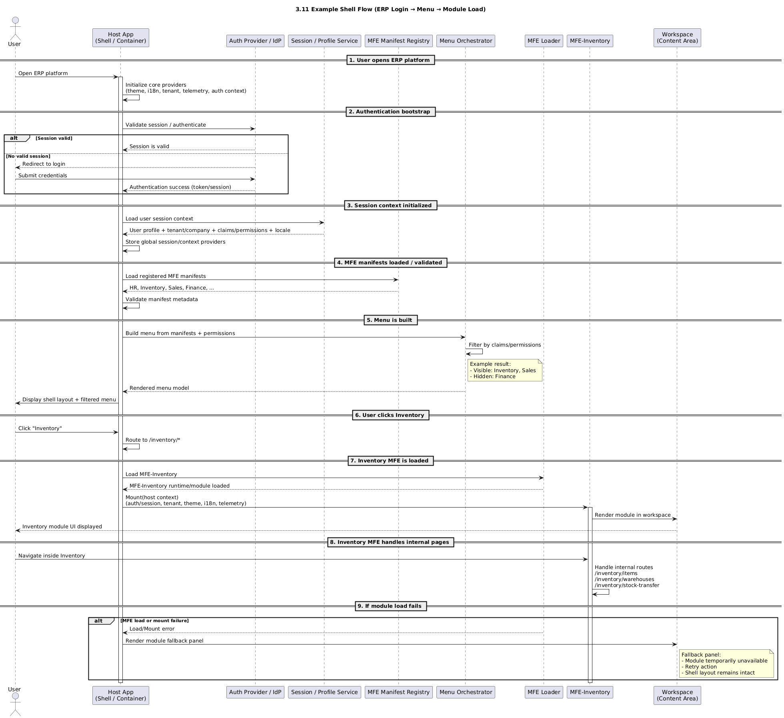
3.11.1 Shell Flow sequence diagram

4. Domain Micro-Frontends (MFE Modules)

4.1 Definition of a Micro-Frontend in This Architecture
In this architecture, a Micro-Frontend (MFE) is a domain-based frontend module integrated into the platform through the Host Application (Shell / Container).
Each MFE is treated as a mini application with:
- clear domain ownership,
- internal routing under a dedicated base route,
- domain UI and workflows,
- and controlled integration with Shell through defined contracts.

4.2 MFE Boundaries and Responsibilities
Each MFE owns its domain-specific frontend scope, including:
- domain pages and workflows
- internal routing under its base route
- domain UI components and screen composition
- Local State and interaction orchestration
- domain API integration adapters
- module-level validations and UI behavior
- module-level telemetry events (aligned with platform standards)

4.3 Base Route Ownership per MFE
Each MFE must have a unique base route. The Shell routes to that base route, and the MFE owns all internal sub-routes.
Example Base Routes
- MFE-HR → /hr/*
- MFE-Inventory → /inventory/*
- MFE-Sales → /sales/*
- MFE-Finance → /finance/*
Example (Inventory Internal Routes)
- /inventory/items
- /inventory/warehouses
- /inventory/stock-transfer
Rule: Base routes are platform-assigned and unique; internal sub-routes are MFE-owned.

4.4 Independent Development and Deployment Expectations
Each MFE should support independent development and, where applicable, independent deployment.
This means the owning team can:
- develop and test the module independently,
- evolve domain workflows without changing unrelated MFEs,
- release changes while maintaining compatibility with platform contracts.
Independence must remain aligned with:
- Shell integration contracts,
- shared package standards,
- routing/manifest rules,
- security and telemetry requirements.
Principle: Independent delivery with platform consistency.

4.5 Do / Don’t Rules for MFE Boundaries
✅ Do
- Do design MFEs around business domains (HR, Inventory, Finance)
- Do keep domain UI and workflows inside the owning MFE
- Do own and manage internal routes under the assigned base route
- Do use shared platform components/utilities for generic reusable needs
- Do follow the Shell integration contract (manifest, mount, host context)
- Do emit telemetry using platform standards
- Do isolate module failures and handle local errors gracefully
- Do keep domain-specific validation and business interaction logic local to the MFE
❌ Don’t
- Don’t import internals from another MFE
- Don’t place domain business logic in shared components/utilities
- Don’t re-implement shell responsibilities (global menu, auth bootstrap, layout frame)
- Don’t own routes outside your assigned base route namespace
- Don’t bypass platform contracts to access shell internals
- Don’t create hidden runtime coupling between MFEs
- Don’t use the shared layer as a dumping ground for module-specific code
- Don’t assume frontend permission checks replace backend authorization

5.1 Clean Architecture (Inside MFE)
5.1.1 Domain Layer
📦 project-root
├── 📁 src
│ ├── 📁 domain # Business Logic (Clean Architecture)
│ │ ├── 📁 entities
│ │ ├── 📁 valueObjects # Optional (recommended)
│ │ ├── 📁 useCases
│ │ ├── 📁 interfaces
│ │ └── 📁 services # Optional domain services
│ │
│ ├── 📁 application # State Management & Application Services
│ │ ├── 📁 services
│ │ ├── 📁 state # Redux / Zustand / Context
│ │ ├── 📁 hooks
│ │ ├── 📁 commands # Optional
│ │ ├── 📁 queries # Optional
│ │ ├── 📁 dto # Application DTOs
│ │ └── 📁 mappers
│ │
│ ├── 📁 infrastructure # External Integrations
│ │ ├── 📁 api
│ │ ├── 📁 repositories # Repository implementations
│ │ ├── 📁 authentication
│ │ ├── 📁 storage # Optional
│ │ ├── 📁 telemetry # Optional
│ │ ├── 📁 cache # Optional
│ │ ├── 📁 mappers
│ │ └── 📁 utils
│ │
│ ├── 📁 presentation # UI Layer (Atomic Design)
│ │ ├── 📁 atoms
│ │ ├── 📁 molecules
│ │ ├── 📁 organisms
│ │ ├── 📁 templates
│ │ ├── 📁 pages
│ │ ├── 📁 routes # Local MFE routes
│ │ ├── 📁 forms # Optional
│ │ └── 📁 viewModels # Optional
│ │
│ ├── 📁 integration # Shell/MFE Integration (Micro-Frontend)
│ │ ├── 📁 manifest
│ │ ├── 📁 hostContracts
│ │ └── 📁 events # Optional (typed UI events)
│ │
│ ├── 📁 bootstrap # MFE mount/unmount entry
│ │ ├── 📄 mount.tsx
│ │ └── 📄 unmount.ts # Optional
│ │
│ ├── 📁 assets # Static files (Images, Icons, Styles)
│ ├── 📁 tests # Unit / Integration / Component Tests
│ ├── 📄 index.ts # Public exports
│ └── 📄 main.tsx # Optional standalone local run entry
The Domain Layer contains the core business concepts and rules of the MFE. It must be independent from UI frameworks, HTTP libraries, and browser-specific APIs.
Typical contents
- Entities
- Value Objects
- Domain Services (when needed)
- Use Case contracts/interfaces (if applicable)
- Repository contracts (interfaces)
- Domain rules / policies
- Domain-specific enums and types
Rules
- No React/UI code
- No API calls
- No storage/browser dependencies
- No framework-specific imports

5.1.2 Application Layer
The Application Layer coordinates use cases and application flow for the MFE. It acts as the bridge between Presentation and Domain.
Typical contents
- Use case implementations / orchestration services
- Application services
- Commands / Queries
- Feature hooks (if treated as application orchestration)
- State orchestration logic
- DTO-to-domain / domain-to-view model coordination
- Workflow coordination (multi-step UI flows)
Responsibilities
- Execute domain use cases
- Coordinate repositories and infrastructure adapters (via contracts)
- Manage application state transitions
- Prepare data for presentation layer consumption (directly or via mappers)
The Application Layer contains workflow orchestration, not UI rendering.

5.1.3 Infrastructure Layer
The Infrastructure Layer contains technical implementations required by the MFE to interact with external systems and platform services.
Typical contents
- HTTP/API clients (domain-specific adapters)
- Repository implementations
- Data source integrations
- Storage adapters (local/session storage)
- Telemetry/logging adapters
- Auth/session adapters (module-level usage)
- Catching implementations
- Error translation adapters
Responsibilities
- Implement repository contracts defined by Domain/Application
- Map external API models into internal DTO/domain input formats
- Encapsulate technical details (HTTP, retry, headers, serialization, etc.)
Infrastructure depends on Domain/Application contracts, never the opposite.

5.1.4 Presentation Layer
The Presentation Layer contains the user interface and interaction logic for the MFE.
Typical contents
- Pages / Screens
- UI components (Atomic Design structure where applicable)
- Local routes (under the MFE base route)
- Forms and validations (UI-level)
- View models / presentation mappers
- UI event handlers
- Loading/error/empty states
Responsibilities
- Render UI
- Capture user interactions
- Invoke Application Layer workflows/use cases
- Display results, validation messages, and state transitions
Presentation handles user interaction and display only; business rules should remain in Domain/Application.

5.1.5 Dependency Direction Rules
To preserve clean boundaries, dependencies must flow inward toward the core business logic.
Allowed dependency direction (recommended)
- Presentation → Application
- Application → Domain
- Infrastructure → Domain / Application contracts
Not allowed
- Domain → Application / Infrastructure / Presentation
- Application → Presentation
- Domain → UI framework / HTTP libraries
- Presentation directly depending on Infrastructure implementation (except through controlled composition/DI setup)
Practical rule
The inner layers (Domain, then Application) must not know implementation details of outer layers.
Dependency principle: Outer layers depend on inner layers; inner layers define the rules.

5.1.6 Use Case and Repository Contract Patterns
This architecture uses cases to represent business actions and repository contracts to abstract data access.
Use Case Pattern
Use cases should represent clear business/application actions, for example:
- GetInventoryItems
- CreateStockTransfer
- ApproveLeaveRequest
- PostJournalEntry
Use case responsibilities
- Validate application-level inputs
- Apply domain rules/policies
- Coordinate repository operations
- Return structured outputs for the Application/Presentation flow
Repository Contract Pattern
Repository contracts are defined in the Domain (or Domain/Application boundary, based on team convention) and implemented in Infrastructure.
Example concept
- Contract: InventoryRepository
- Implementation: HttpInventoryRepository
This keeps domain/application logic independent from API/DB transport details.
Pattern Guidelines
- Keep contracts business-oriented (not HTTP-oriented)
- Avoid leaking transport models into Domain
- Return domain objects or application DTOs (by convention), not raw API responses

5.1.7 State Management Placement Rules
State management should be placed according to scope and responsibility, not library preference.
Recommended placement by state type
A) Presentation/UI State (Presentation Layer)
Examples:
- modal open/close
- selected row
- form field temporary values
- local filters/sort UI controls
- tab selection
B) Application/Workflow State (Application Layer)
Examples:
- multi-step process state
- orchestration state for commands/queries
- feature-level loading/status transitions
- module-level data coordination across multiple screens/components
C) Domain State (Domain Layer)
Domain state should exist as part of:
- entities
- value objects
- domain rules/policies
—not as framework-managed UI store state.
Rules
- Do not place domain business rules in UI stores
- Do not make the global/shared store the default for module state
- Keep state local to the MFE unless explicitly platform-wide
- Prefer feature-scoped state over broad module-global state when possible
Placement principle: UI state in Presentation, workflow/application state in Application, business rules in Domain.

5.1.8 DTO and Mapper Guidelines
To avoid coupling between layers and external APIs, this architecture uses DTOs and mappers explicitly.
DTO Types (Recommended Separation)
- Request/Response DTOs (Infrastructure/API-facing)
- Application DTOs (use case inputs/outputs, if needed)
- View Models / Presentation Models (UI-facing)
Mapper Responsibilities
Mappers transform data between boundaries, for example:
- API response → Application DTO / Domain entity
- Domain entity → View model
- Form model → Use case input DTO
Guidelines
- Do not expose raw API response objects directly to Presentation
- Do not use UI form models as Domain models
- Keep mapping logic centralized (mappers/adapters), not scattered across pages/components
- Prefer explicit mapping over implicit field spreading for critical business objects
Naming Suggestions (optional convention)
- InventoryItemApiDto
- InventoryItemDto
- InventoryItemViewModel
- InventoryItemMapper
- InventoryItemViewModelMapper
Mapping principle: Each layer should work with models shaped for its own responsibility.

